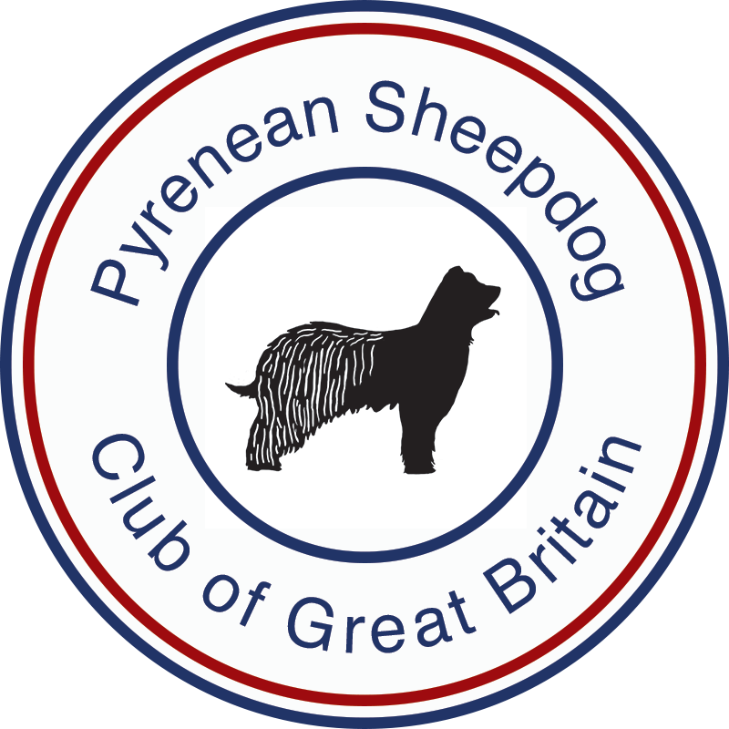

**Pyrenean Sheepdog**

**(Long Haired)**

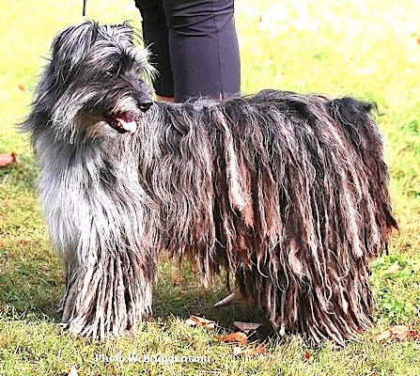

* Minimum Size and Weight – Maximum Energy.
* Alert, Inquisitive but Wary of Strangers.
* Strong Herding Instinct.
* Windswept Appearance.
* Small, Cheeky, Stubborn and Sensitive.

.

**Who is the Pyrenean Sheepdog?**

The Pyrenean Sheepdog is a brave little dog, resourceful, capable of initiative and entirely devoted to his owner. They have a fairly independent nature and good training is needed to channel their energy and make the most of their intelligence and alertness. They are often suspicious of strangers. A Pyrenean Sheepdog can uniquely be both stubborn and sensitive, so a patient and knowledgeable owner, is required to train them well. They are quite small with a cheeky look and it is easy to be taken in by this and the result is usually a dog that “rules the roost”. Don’t lose sight of the fact that they are firstly bred to be a sheepdog and are still found working sheep today. They want to work with their owner but need to have some way of channelling their enormous energy. The approach to this dog is best summed up in the words of the Basque Shepherds from the Pyrenees when they say *“ He will be a willing partner but never your servant”.* This is a dog that can excel at canine sports - tracking, obedience agility, working trials – as well as obviously herding. They need good training with a partnership approach that earns their respect along with plenty of exercise. They are bundles of energy.

**What does he look like?**

The body is longer than it is tall and the head is small with a triangular shape. Ears are short and triangular and the eyes are almond shaped. They carry single or double dewclaws on the hind legs, (both are permitted).

The coat is harsh and dense, resembling a combination of goat’s hair and sheep’s wool. It should be a softer more dense “sheep’s wool” texture on the rump, the head coat should never conceal the eyes, it should be very short on top of the muzzle and the longer hair on the cheeks and face should sweep back to create a ‘windswept’ effect. It needs moderate grooming with no stripping or trimming necessary. The coat can form Cadenettes, a type of felted cord, on the back half of the body where it has a dense woolly texture. The coat also comes in a demi-long form and as the name suggests the hair length is not as long as the “Sheep’s Wool” type, with significantly less undercoat and quite a harsh textured top coat. In addition the leg hair is less dense with only light fringing on the legs. The “Demi Long” does not develop “cadenettes” and in the main is a trouble free coat that requires minimum maintenance.

The predominant colour of the breed is fawn of varying shades; other colours are light to dark grey, black, blue merle, slate blue or brindle.

Height: Dogs 40 – 48 cms. (15 ½ - 19 ins.) Bitches 38 – 46 cms. (15 – 18 ins.) They live to well over 12 years as a rule and 15 years is quite common.

**What health problems do they have?**

Hip dysplasia and PDA (Patent Ductus Arteriosis) have been found within the breed. All breeding stock must have their hips x-rayed and scored under the BVA/KC scheme and all puppies must be screened for PDA before they leave the breeder. There has been an incidence of epilepsy and the club is continuing to gather information to monitor this.

**Is the Pyrenean Sheepdog for you?**

The Pyrenean Shepherd is a remarkable dog, but can be quite demanding. This is a dog best suited to an active country lifestyle, but with adequate exercise and companionship can cope in more urban environments. The most important thing for a Pyrenean Sheepdog is to be with their owner – this is not a dog suited to being left alone for long periods. This is a dog that must be occupied or they can become noisy and difficult to live with. Having said that given enough exercise and plenty to do it is a dog that you can take anywhere with you. They can become very possessive of their owners and members of the family, so needs very good socialisation from a very young age. They should not be nervous or aggressive even if they can appear “stand-offish” with those they don’t know.

These dogs require a lot of exercise, at least an hour free running every day. The coat is not hard to care for and can be managed with a short grooming session once a week. You will need to have the time to commit to this dog and knowledge and patience to train him well. We don’t recommend this as a dog for a first time owner.

**History and Origins of the Breed**

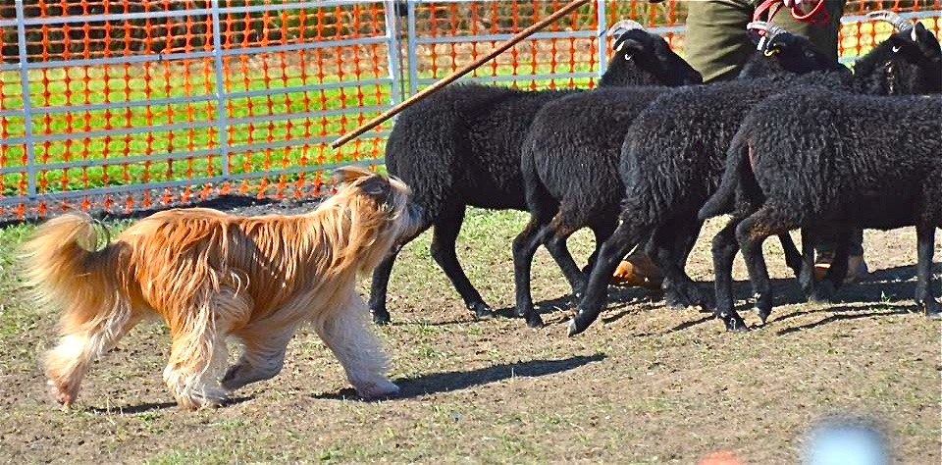The Pyrenean Sheepdog is known in its native country as Le Berger des Pyrénées. It is a very old indigenous breed that has always remained in its place of origin, the high mountainous region of the Haute Pyrénées in the Central Pyrenees. It is small in comparison with other sheepdog breeds, but this does not demean its ability to work tirelessly, sometimes from dawn to dusk herding large flocks of sheep. Its loyalty and willingness to obey its master drives it on to cover many miles in a working day.

The breed has ancient origins and is well known in its area of origin but formal recognition of the breed outside of this really began at the turn of the last century when during the 1914-18 war it was used by the French Army as a messenger dog where it excelled due to its speed and intelligence, although the very high losses took their toll nearly wiping out the breed.

After the war enthusiasts rallied their support and during 1922 the foundations for the Reunion Amateurs des Chien Pyrénées (RACP the French Breed Club) were set. Shortly after in 1926 the breed standard was recognised and accepted by the French Kennel Club the SCC.

The first Pyrenean Sheepdogs were registered with the Kennel Club in 1988, and numbers in the breed have increased very gradually. The Pyrenean Sheepdog Club of Great Britain was formed in 1992. The club worked to set an Interim Breed standard and the breed came off the Import register in 2006 with the first classes for dogs at Crufts being held in 2008.

In the UK Pyrenean Sheepdogs are still relatively uncommon with very small numbers of puppies being registered each year. However there are dogs that are competing in agility, obedience, flyball, working trials and cani-x as well as a small number of dogs herding.

**Pyrenean Sheepdog – Face Rase**

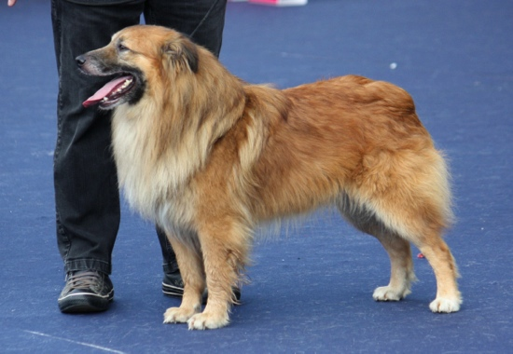There are two different variants of Pyrenean Sheepdog – the Long Haired (or Poil Long) and the Face Rase. The Face Rase has a softer, shorter coat with the hair on the face and muzzle in particular very short giving a shaved appearance. The body is shorter and the overall appearance is of a more square shaped dog. This type is also taller (up to 20 ins at the shoulder). The Face Rase is less common in the UK and is not yet recognised by The Kennel Club. There are, however, now two breeders in the UK so the club anticipate numbers to gradually increase.

For more information contact:

The Pyrenean Sheepdog Club of Great Britain

www.pyreneansheepdog.co.uk

**Chairman**: Eion Flint

**Email**: [sandytrail@btinternet.com](mailto:sandytrail@btinternet.com)

**Tel**: 01751432599

**Secretary**: Vikki Lucas

**Email**: [Shiningtor.PSD@gmail.com](mailto:Shiningtor.PSD@gmail.com)

**Tel**: 07790095355